Stocker
DISCLAIMER: Stocker is NOT financial advice. The stock market is NOT risk-free no matter your strategy or your confidence. Stocker is a passion project and should be treated as nothing to take concrete decisions from. Any financial decisions that the user takes are of their own doing and the owner is not responsible for any potential losses. The USER is accountable for any profits/losses that they make, and should not keep the Stocker app or its creator accountable. The creator of the app is not qualified to give financial advice.

INSTRUCTIONS. READ CAREFULLY BEFORE PROCEEDING
- Updates:
- The configuration of the program requires updating when accuracy drops significantly.
- It is not recommended for the user to do any sort of model retraining or backtesting in the app’s interface, due to the fact that those functions were designated for older versions of the model and will most likely ruin accuracy.
- The stock market evolves constantly, and sometimes – rapidly.
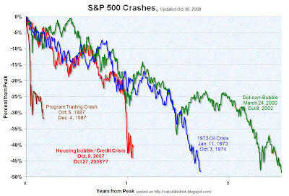
- Market Crashes
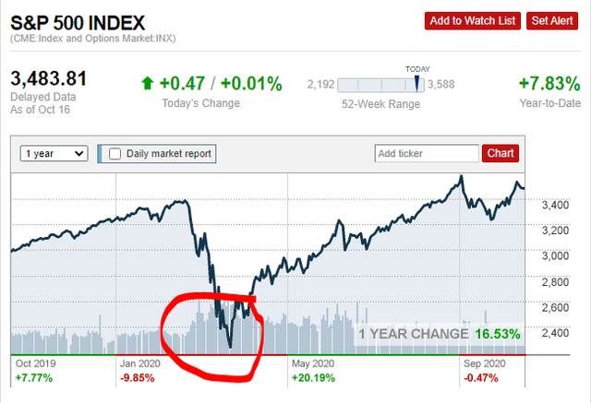
- It is UNKNOWN how the program will react during a recession, so use at your own risk. A rule of thumb: recessions happen constantly. In the case of a recession it might take years for an investor’s stocks’ prices to go back to their previous worth, IF they ever do.
Examples of recessions
Those are examples of the S&P 500, which is known to recover from recessions. Your stocks might not.
- Stocks recommendations
- In the case that the user is informed of the dangers behind stock market investing, then they must know that they must choose healthy and reliable stocks. NONE OF THE RECOMMENDATIONS HERE ARE FINANCIAL ADVICE.

- How to use the app
DO NOT change the Strategy from anything other than Trading. Neither Mixed nor Investing is calibrated, and probably won’t be.
- Load up the stocker app.
- Go to the Gun tab.
- Load up the stocks you desire to analyze.
- Click on the FIRE button and wait for the process to finish.
- Go to the predictions tab.
- Make sure everything is okay.
- If the need to analyze individual stocks arises, then scroll up inside the predictions tab, insert the symbol you want to analyze in the Stock Lookup section, click on Analyze Stock and wait. After process has finished, then click on the Analysis tab. If you wish to do so, also click on the Market Intel tab.
- TABS THAT ARE RECOMMENDED NOT TO USE DUE TO CHANCE OF MALFUNCTION: Seeker AI, Risk Management, Advanced Analytics, Walk-Forward Backtesting, ANYTHING related to the AI Training Status section on the left of the screen.
- Functions with unknown capabilities (that you probably won’t need anyways, so just don’t use them): Analyze Predictions, Find Market Dips, My Holdings, Alerts (can be done via any financial broker), Potentials,
- The dashboard is the safest way to look at a stock’s prediction. If the user wishes to do so, they can click on any active prediction inside the dashboard and get detailed reasoning behind why the investment has a BUY signal. The paper trader does not work and probably will NOT be fixed due to the high chance of system malfunction.
- PERSONAL analysis is highly recommended, as the app is NOT FINANCIAL ADVICE and should not be treated as such.

